Please go to [www.Jituzu.com.](http://www.jituzu.com./) And click on 

1. Click on “I’m a Service Provider and my business is already registered. 
2. Complete all of the Account information and Settings and submit the information.  Use the provider’s log in for MCP if possible and the same password. Use the same security questions and answers and complete the forms as follows:

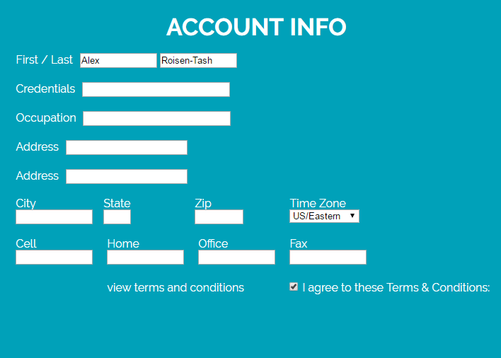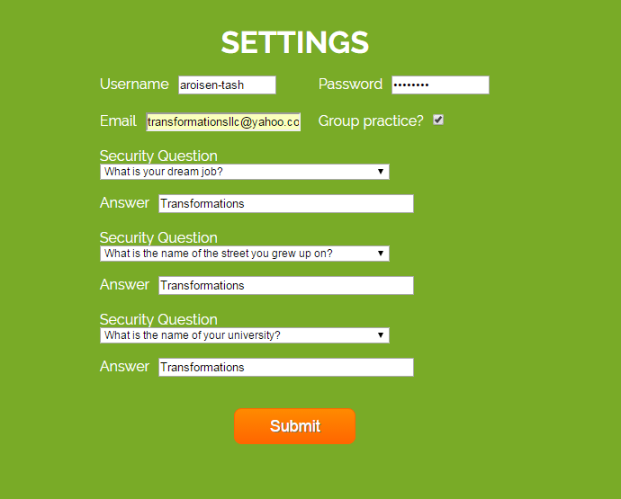

1. Then click the orange submit button
2. Then click on  in the green tool bar.
3. Then click on Join EXISTING 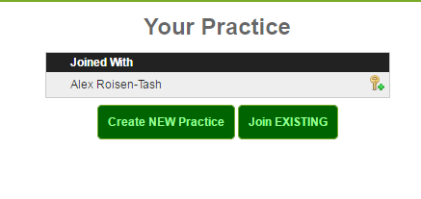
4. Then type in the name transformations and click “go” 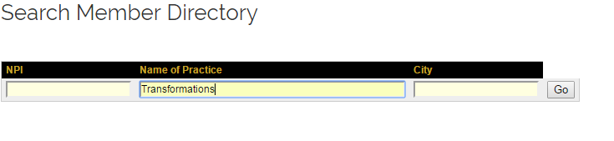
5. Next you will see a drop down box with transformations listed several times. Select the one in all capital letters. A mail box will pop up. Type in the provider’s name and click “Send”:

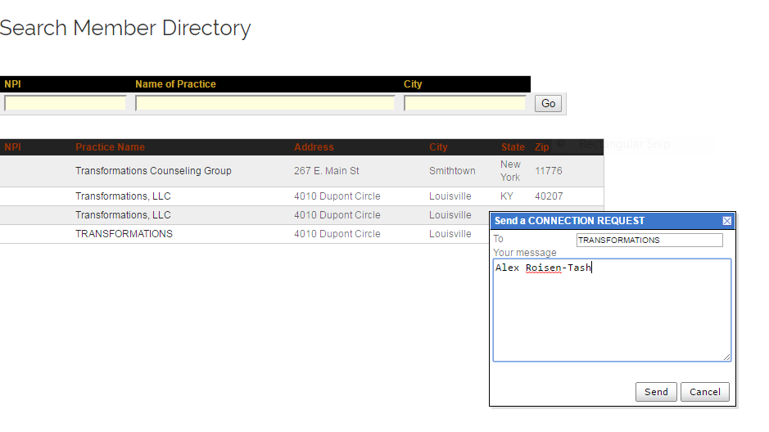

1. Then you will see in red that the email was sent:

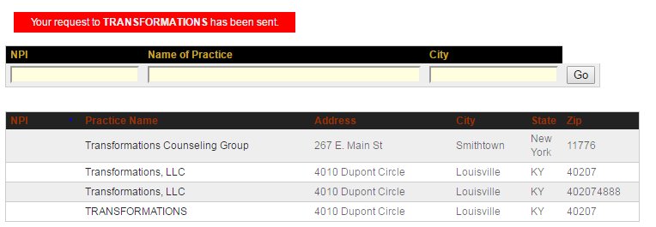

1. Log out of the account by clicking in the green tool bar. 

After you have set up all of the providers:

1. Log into the main account (tlloyd)in MCP and click on My Calendar in the main menu: 
2. Then click on the In box: 
3. Check box the name of the providers to be joined to Transformations account.

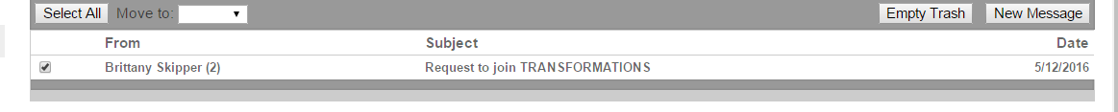

1. Click on the provider’s name and the following box will open up. Mark the circles indicated and click Save

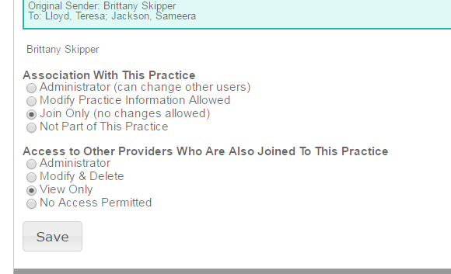

5.  When you have accepted all of the providers, you can log out of your account.

Next we ned to link the Jituzu accounts to MCP accounts

1. Log into MCP as tlloyd. Use her password.
2. Click on the calendar app, 
3. Click on My Account 
4. Click on 
5. Enter the following information

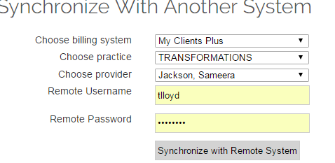and click to synchronize

1. Select the correct provider account

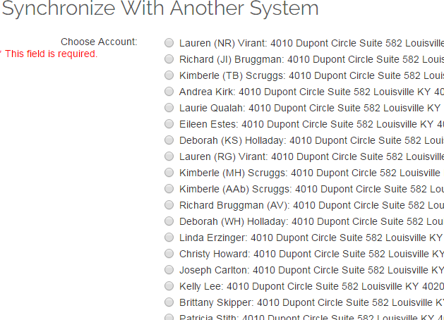

1. Scroll down the list and click on the synchronize button

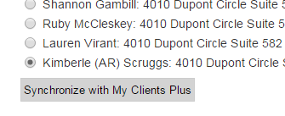

1. The account is successfully linked when you see this page.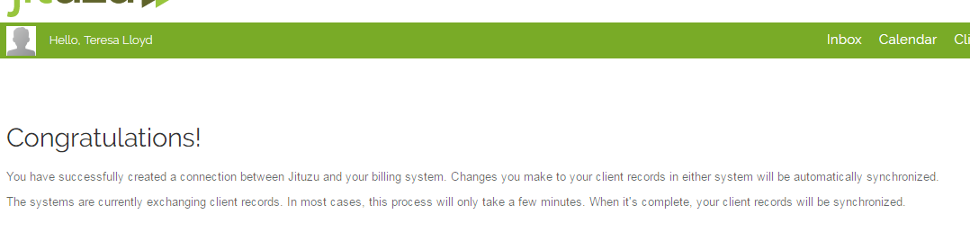

If we can be of further assistance, please let us know. ​

Best Regards,

Jacqulyn Nelson

My Clients Plus, LLC & Jituzu

Jnelson@myclientsplus.info

**(877) 820-4153** toll free

**(800) 783-6267** fax