How to add or edit a user profile on Transformations website

Go to [www.transformationsllc.net](http://www.transformationsllc.net)

Login as ****** with password *******

On the top left of the screen in the black tool bar hover over the word Transformations



A black menu will drop down, select and click on Dashboard.

You are now inside the website and can make changes to the appearance of the site. Please be careful as changes are permanent and cannot be undone.

Once you have clicked on Dashboard you will see a black tool bar on the left side of the screen. Scroll down and click on User.

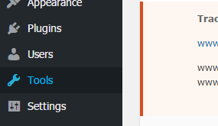

Then look at the top left corner and click on add new user.

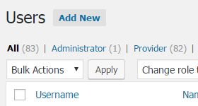

Here is an example of to add information to the screen.

Use the person’s first initial and last name as the username

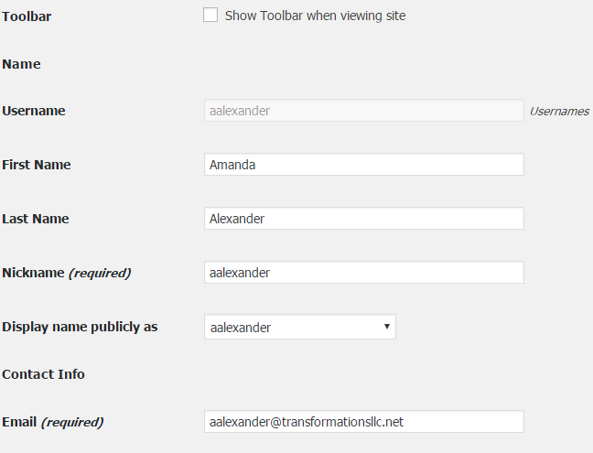

Click on show password and enter the password. I recommend using the same password for the email system, MCP and the website.



Then click add new user.

Scroll down to the Extra Fields.

Edit the check marks to indicate the correct service fields. All of them will be checked if you do not do this.

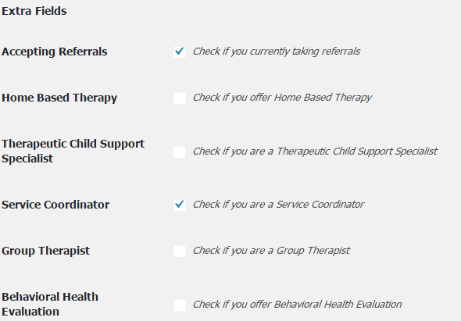

Next you want to take the information on the Website Form filled out by the provider when they contracted with the agency.

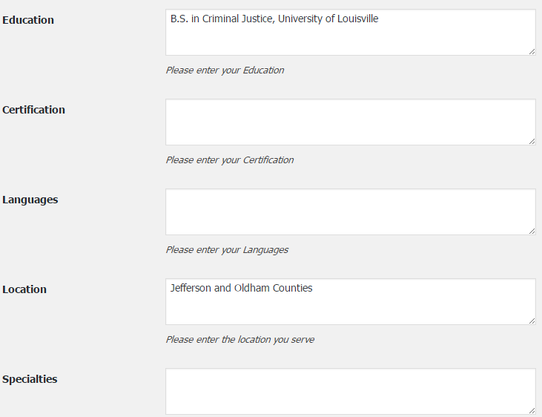

Certifications refer to licenses such as a Licensed Marriage and Family Therapy Associate or a Clinical Social Worker. Do not use LPCA or LMFTA designations as they are not permitted by their licensing boards. Look at other listings currently on the website and use similar language style and font for uniformity and neatness. Leave Languages blank and do not type English unless the provider speaks another language like Spanish or American Sign Language. Type these in. Add location the provider prefers. Specialties may be left blank if the provider does not have a specialty. Again look at the website for uniformity with other entries.

Other (client comments) can stay blank until later when we receive survey feedback on the provider.

To add a head shot of the provider, click on choose a file. You should have already prepared a photo for uploading. The provider should send you a professional photo or they can upload it themselves. If they upload it you will need to monitor it for appropriateness.



Current Status is an important box. Check yes only if you are ready to post this provider profile to the website as ready and available to accept clients. Leave it blank if the profile is missing information or not ready to provide the services.



Fill in the providers phone and fax number. The fax maybe left blank. These numbers are available to the staff only once they sign into our website. They are not posted on the public page.

Insurance accepted must be filled into save this form. If the provider is under clinical supervision, open up the supervisor’s profile and copy and paste the insurance companies the supervisor is approved to provider. The provider is eligible to bill for the insurance companies of their supervisor.

CAQH number is needed for licensed providers. Leave it blank if the provider does not have a CAQH number.

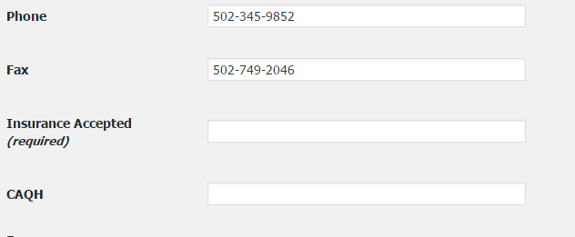

Skip down to User Update and click on the button. This will save the profile and post it to the website as indicated.



To check your work and spelling, hover the curser over the word Transformations in the black tool bar across the top of the page. Then click on Visit Site. You are now back at a public view.

You can edit this profile with these same instructions. This profile should be receiving new fields soon as our web developer is working on the site.