How to bill services with Omni Visions

Open up My Clients Plus in a google chrome browser

The client set–up will have the following data entered under “Send Invoice To”

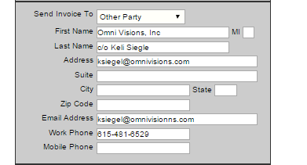

The insurance section of client-session will be left blank.

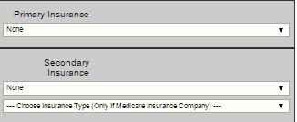

The BHP will enter a bill and a note for each service.

The bill will be a short form.

The BHP will enter the Diagnosis Code is 90000 Omni Visions psychotherapy services.

Then the BHP will write a note to document the services.

The BHP will send a to-do notice to his or her billing supervisor.

The billing supervisor will review the note and generate a claim.

The office staff will generate an invoice for Omni Visions.

1. Go to 
2. Select Client’s name
3. Select the date for the previous month, e.g. 1/1/2016 to 1/31/2016.
4. Then print the account statement: 
5. Select “Standard Report”
6. Click on 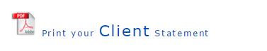
7. Print the report
8. Change the destination to PDF rather than the printer-this works if you use Chrome browser
9. Save the account statement on your computer
10. Next download the notes for the month to go with the invoice.
11. To download the notes click on 
12. Select the client name
13. Select the client name and choose any session date.
14. Click on the red print button
15. Select the beginning and end dates to correspond with the invoice.

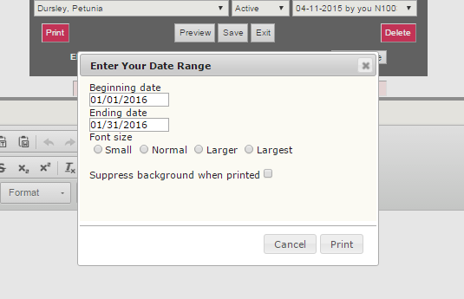

1. Then click print.
2. Then change the destination from the printer to PDF file. This works in the Chrome browser.
3. Save the notes on your computer
4. Email the notes and account statement as an attachment to Omni Visions c/o Kelli Siegel at ksiegel@omnivisions.com.