How to bill services with Omni Visions

The client set–up will have the following data entered under “Send Invoice To”

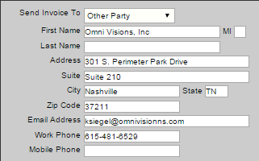

The insurance section of client-session will be left blank.

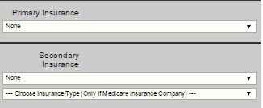

The BHP will enter a bill and a note for each service.

The bill will be a short form.

The BHP will enter the Diagnosis Code is 90000 Omni Visions psychotherapy services.

Then the BHP will write a note to document the services.

The BHP will send a to-do notice to his or her billing supervisor.

The billing supervisor will review the note and generate a claim.

The office staff will generate an invoice for Omni Visions.

1. Go to 
2. Select Client’s name
3. Select the date for the previous month, e.g. 1/1/2016 to 1/31/2016.
4. Then print the account statement: 
5. Select “Standard Report”
6. Click on 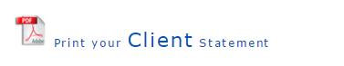
7. Print the report
8. Use this printed report to fill out the Omni Visions Invoice. Click here for copy.
9. Next print the notes for the month to go with the invoice.
10. To print the notes click on 
11. Select the client name
12. Select the client name and choose any session date.
13. Click on the red print button
14. Select the beginning and end dates to correspond with the invoice.

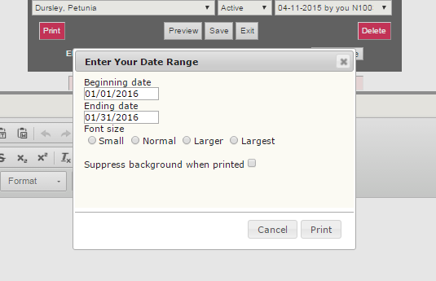

1. Then click print.
2. Mail the notes, account statement and invoice to Omni Visions.