How to post paper claims for primary insurance companies

1. Select 
2. Click on Enter a New Item 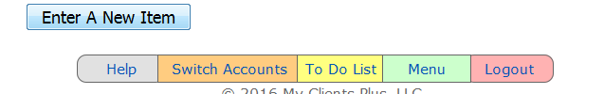
3. Then choose From Insurance 
4. Then select the insurance company that was billed for the paid claim. Select paper if the clai was billed by a paper or electronic if the claim was sent electronically.
5. Put in the date of the EOB and the Check # and the total amount paid

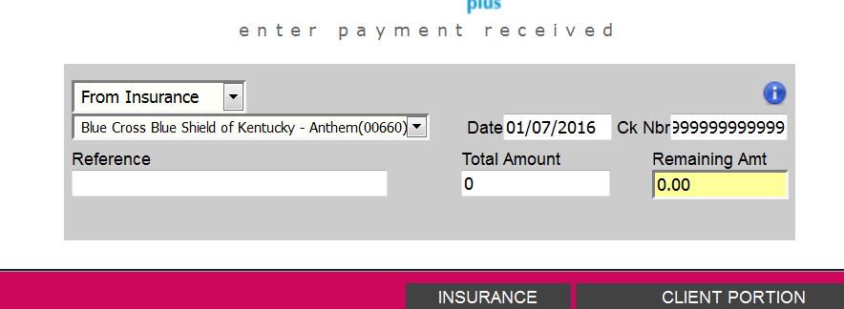

1. Next find the line with the same date of service from the EOB

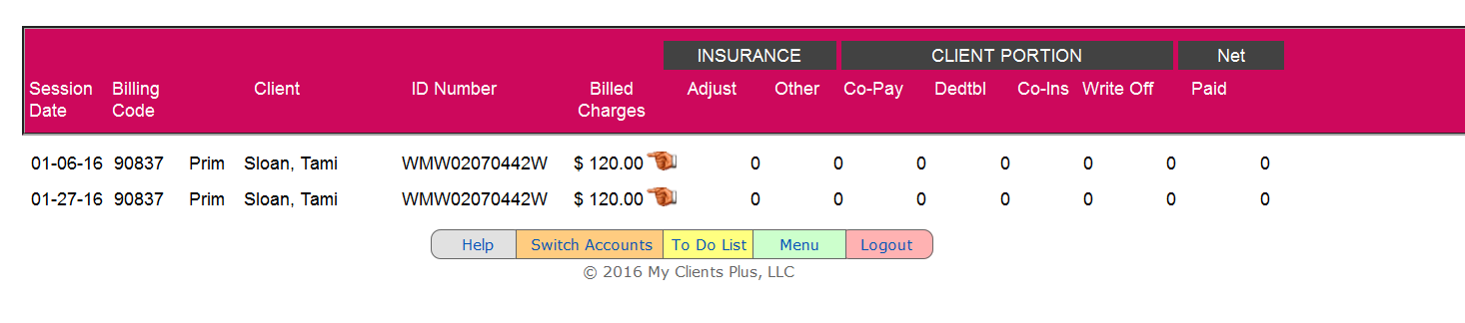

8.Click on the hand sign 

9. Subtract the amount paid from the amount charged and enter the amount not paid in the co-pay box. In this case the session charge was 120.00. The primary insurance paid 79.10. The remaining amount is $40.90

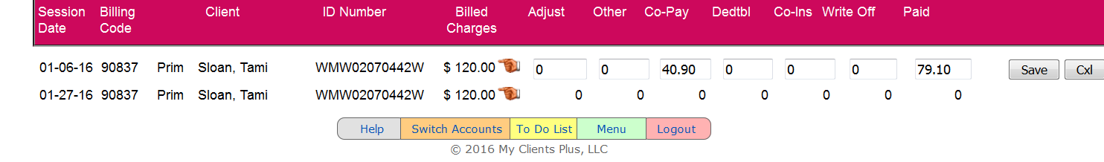

10. Click Save 

11. If you have more to add click on Keep Working. If you are finished click on Update Account Balalnces.

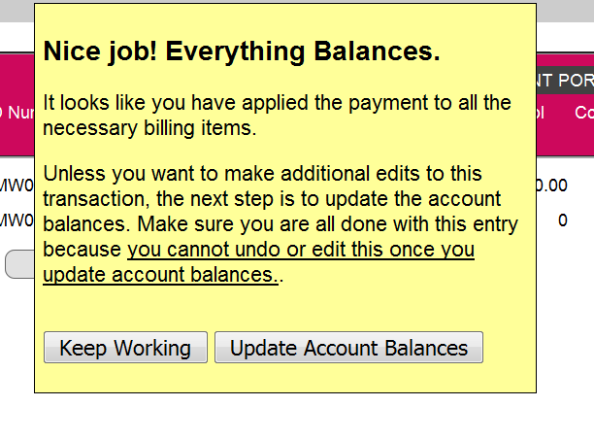

10. Make a copy of the paper EOB and high light the date of service. Make a separate copy for each date of service.

11. Once this is complete, the secondary claims are ready for review and printing.