How to set up a new provider in My Client’s Plus

1. Go to [www.myclientsplus.com](http://www.myclientsplus.com)
2. Click on 
3. Fill out form, skip the psychology today offer, create a log in.
4. Create a password that begins with a four letter word, capitalize the first letter, and end with last 4 digits of provider’s phone number. Make it something you can remember.
5. Send a copy of the sign up complete notice to the provider and retain info for agency records of login and password
6. Click here to log-in
7. Go to menu and click on 
8. Click on and enter credit card formation
9. Then click on in the main menu
10. Then fill out the provider information. If a provider is under clinical supervision the supervisor’s name, NPI, taxonomy and license will be entered here. Put the new provider’s initials in parentheses after the supervisor’s first name and the new provider’s full name in the box after the supervisor’s last name. The group NPI and taxonomy belong to Transformations and is the same for all providers. We also list all types of provider’s as Marriage and Family Therapist under type of practice.
11. Next you will attach this account to the administrative accounts: rklein, tlloyd, lalewis, jpolley, schowdery, jeffrose. Also attach the account to the new provider’s billing supervisors.
12. In order to do this you must log in to the administrative person’s account.
13. Then click on My Account in the main menu
14. Then click on 
15. Then enter the new provider’s log in and password. Saving this should add the new provider to the administrator’s provider list.
16. Go back to the new provider’s account and click on My Account and then click onand set the new provider’s privileges as follows:

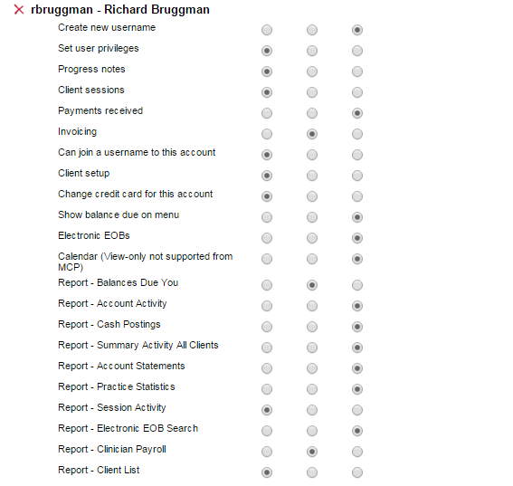

1. Then set the amin priviledges as Full Access and Billing supervisor to the following settings:

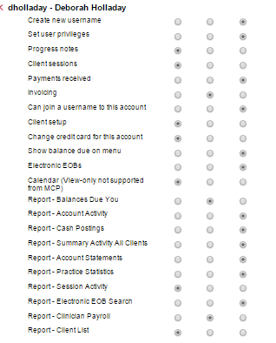Save these settings.

1. Then go back to the main menu and then to My Account. Click on 
2. Begin copying files from an established provider to the new provider’s account

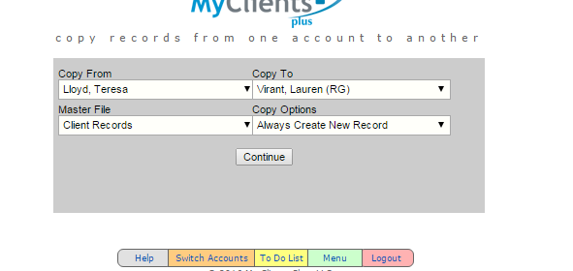

1. Teresa Lloyd is good for Harry Potter client records. Select Harry Potter to copy to the new provider. You will have to add the insurance info to the client set up. Use Passport. You will also need to upload example diagnostic evaluation and enrollment packet.
2. Then do the same with the Insurance records 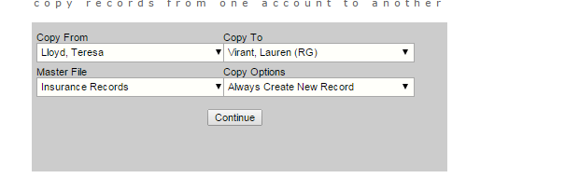
3. Then the same with the diagnostic codes and in the Billing codes. Use Robin Goben or a new provider name for the diagnostic codes that does not have all of the old DSM diagnoses on the list.
4. The new provider should now have a fully operational account.
5. Notify [dwarren@myclientsplus.info](mailto:dwarren@myclientsplus.info) of the new account so that she will add it to our discount list.