I have read the article Sexual Attraction in the Therapeutic Relationship by Steven M. Harris, PhD and participated in a staff discussion facilitated by Transformations.

Signature 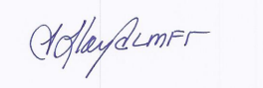

Name Teresa Lloyd

Title CEO

Date 4/4/2024

